Introduction to Proteus Simulation tool

Proteus Professional is a software tool used for electronic circuit design and simulation. It is widely utilized by engineers, students, and hobbyists for developing and testing circuits before they are physically implemented. Proteus8 Professional, often simply referred to as Proteus, is one of the latest versions of the software, offering advanced features and capabilities.


Here is a brief introduction to Proteus8 Professional:

- Electronic Circuit Design:

  - Proteus allows users to design electronic circuits using a user-friendly schematic capture interface. You can create circuits by placing and connecting components such as resistors, capacitors, transistors, and ICs.
- Simulation:

  - One of the key features of Proteus is its powerful simulation engine. Users can simulate the behavior of their circuits before building a physical prototype. This helps in identifying and rectifying potential issues and errors in the design.
- Mixed-Mode Simulation:

  - Proteus supports mixed-mode simulation, allowing the simulation of both analog and digital components in the same circuit. This is particularly useful for projects that involve both types of components.
- Microcontroller Simulation:

  - Proteus includes a wide range of microcontroller models, enabling users to simulate and test embedded systems. This feature is valuable for those working on projects involving microcontroller-based designs.

- PCB Layout Design:

  - After designing and simulating the circuit, users can proceed to the layout design phase. Proteus provides tools for creating professional-looking printed circuit board (PCB) layouts. Users can place components, route traces, and generate manufacturing files.
- Real-Time Interaction:

  - Proteus supports real-time interaction with the circuit during simulation. Users can observe the behavior of the circuit and monitor various parameters in real-time, providing valuable insights into the design's performance.
- 3D Visualization:

  - Proteus8 Professional enhances the user experience with 3D visualization of the PCB layout. This feature allows users to view the PCB in a three-dimensional space, aiding in the identification of design issues and improving the overall design process.
- Libraries and Components:

  - The software comes with an extensive library of components and models, covering a wide range of electronic devices. Users can also create custom components to meet specific project requirements.
- Educational Use:

  - Proteus is widely used in educational institutions for teaching electronic circuit design and simulation. It provides a hands-on approach to learning and allows students to gain practical experience in a virtual environment.
Overall, Proteus8 Professional is a comprehensive tool that facilitates the entire electronic design process, from schematic capture to simulation and PCB layout. It is an invaluable resource for professionals, students, and hobbyists involved in electronics and circuit design.

Contents :-
- Rectifiers
  - Half Wave Rectifier
  - Half Wave Rectifier with Capacitor
  - Bi-phase Full Wave Rectifier
  - Bi-phase Full Wave Rectifier with Capacitor
  - Bridge Rectifier

- Voltage Multipliers: -
  - Voltage Doubler
  - Voltage Tripler

- OPAMP Circuits: -
  - Inverting Amplifier
  - Non-Inverting Amplifier
  - Differentiator
  - Summer
  - Astable oscillator

- Adders: -
  - Half Adder
  - Full Adder

- Modulators:
  - Amplitude Modulation

- Rectifiers
  - ​Half wave rectifier: -
The circuit diagram of half wave rectifier is as shown in the figure below:-
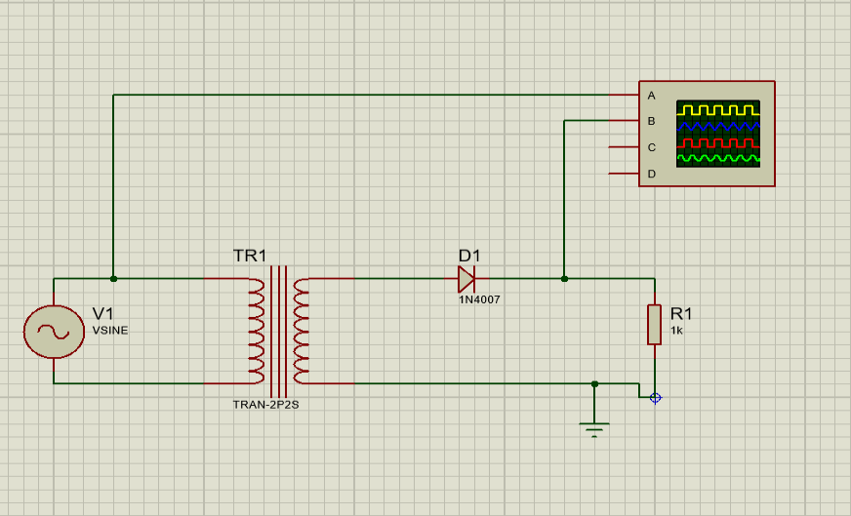
The main voltage is 240V, 50Hz, is applied to the primary step-down transformer, which will be reduced to 12V rms across the secondary.
During the +ve half cycle of the secondary, the diode is forward biased and conducts current through R1.
During the -ve half cycle of the secondary, the diode does not conduct current through R1 and the cycle repeats.
The input and output voltage waveforms is as shown in the figure below:-
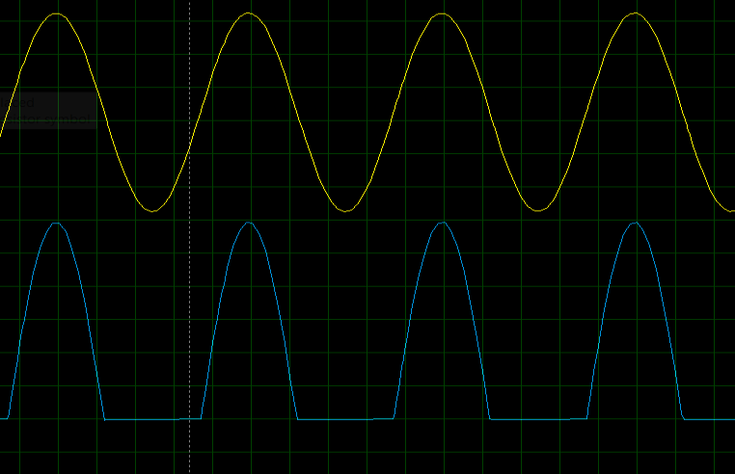

  - ​Half wave rectifier with Capacitor: -
The figure shows a Half-Wave Rectifier (HWR) with a capacitor filter, where the capacitor is connected in parallel with the load.

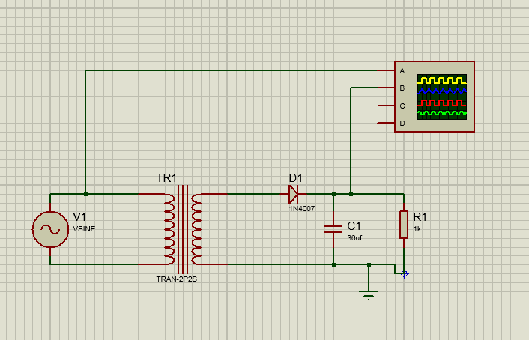

The capacitor is called a reservoir capacitor. It stores charge during the positive half-cycle of the secondary voltage and discharges through during the negative half-cycle of the secondary voltage.
During the first half of the positive cycle of the secondary, the diode D is forward-biased and charges the capacitor.
During the second half of the cycle, the entire voltage of the secondary is in reverse bias, and the capacitor discharges through RL. The discharge time is slow, and the cycle repeats. By observing the capacitor voltage, the ripples are reduced
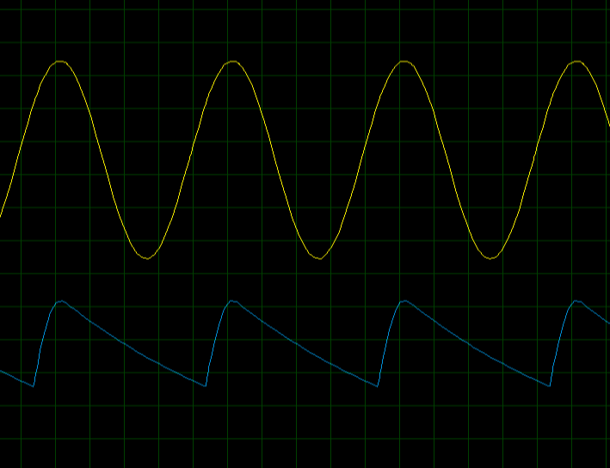
  - ​Bi-phase full wave rectifier: -
It is constructed by using centre tap transformer and 2 diodes

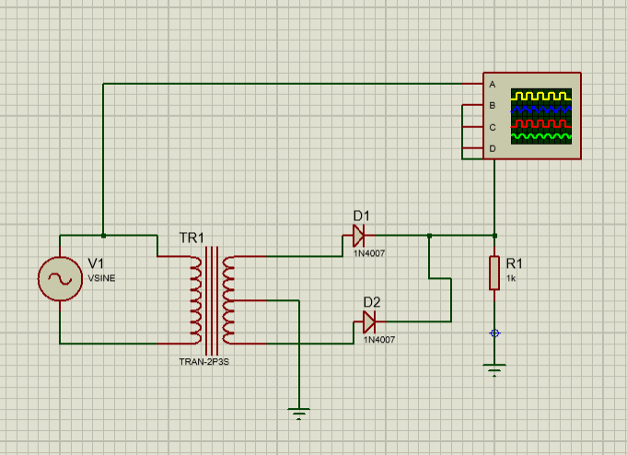
During positive half cycle of primary, the D1 is forward bias and conducts current through R1. The D2 is reversed bias and does not conduct current.
During negative half cycle of primary, the D2 is forward bias and conducts current through R2 in the same direction as that of during positive half cycle and D1 is reversed bias and does not conduct current as shown in the waveform below
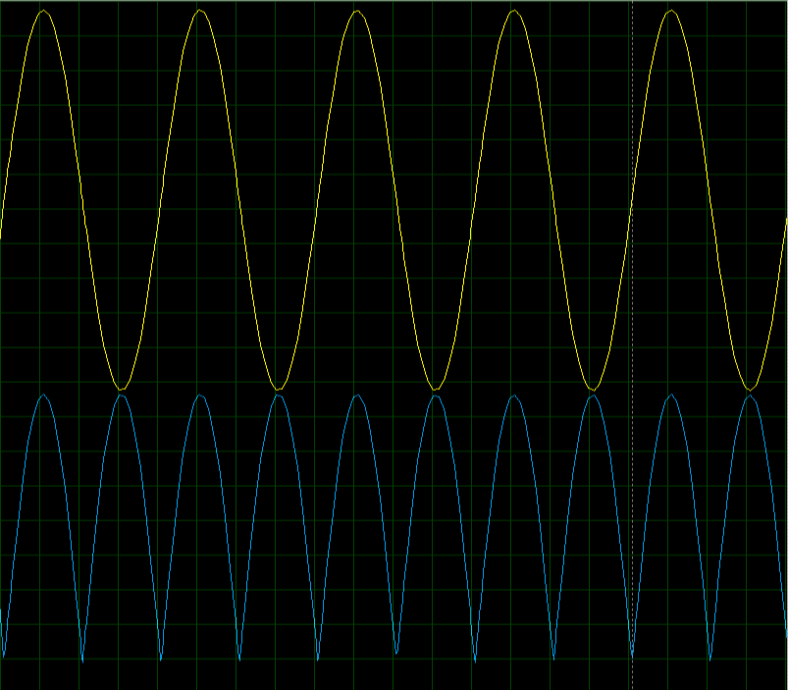
  - ​Bi-phase full wave rectifier with capacitor: -

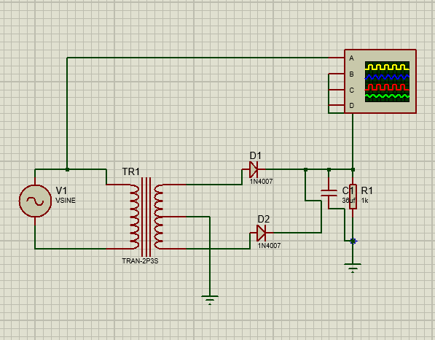

The capacitor filter is used to remove the ripples. During the positive half cycle, the capacitor is charged to the peak value of secondary due to Diode D₁. When the secondary becomes less than peak value, both D₁ and D₂ will be reversed biased and capacitor discharges through R₁. During the negative half cycle, the capacitor charges again due to Diode D₂. The charging time is very fast and discharge time is slow.
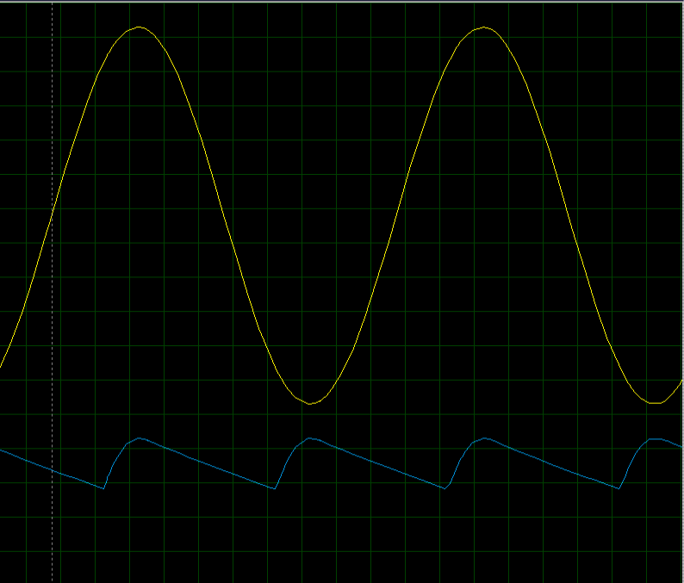

  - ​Bridge rectifier: -

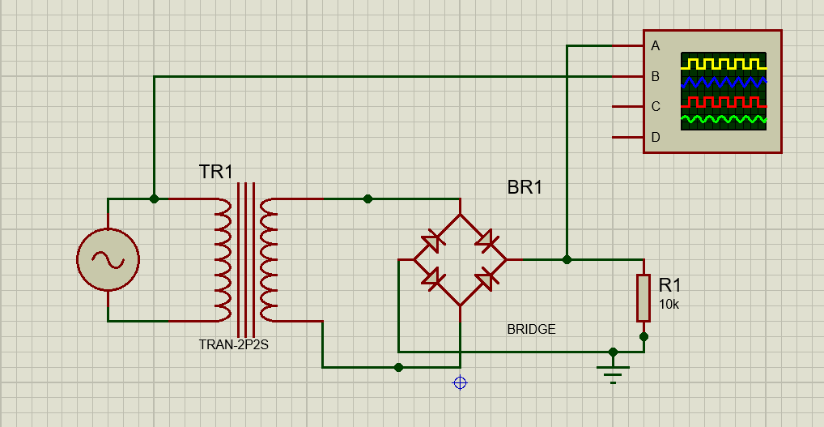

During positive half cycle of the secondary, the diode D₁ and D₂ are conducting current through R₁, and D₃ and D₄ are reversed bias. During negative half cycle of the secondary, the diode D₃ and D₄ conduct current through R₁, and D₁ and D₂ are reversed bias.



- ​Voltage
  - ​Voltage Doubler: -
It can be constructed by using an additional diodes and capacitors with the half wave rectifier as shown in the figure below:
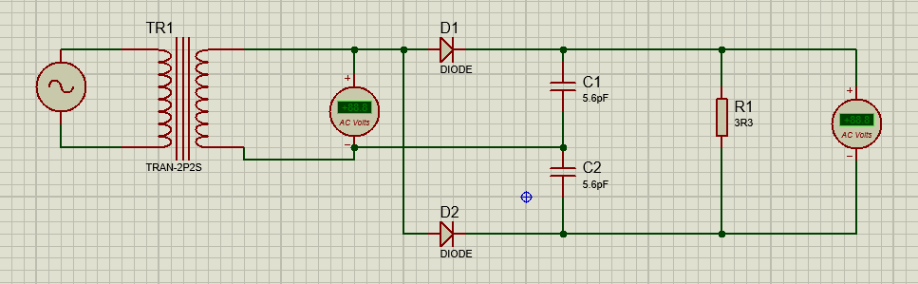

During +ve half cycle of secondary, D₁ is FB, and C₁ is charged to peak value Vpk.
During -ve half cycle of secondary, D₂ is FB, and C₂ is charged to the peak of secondary Vpk.
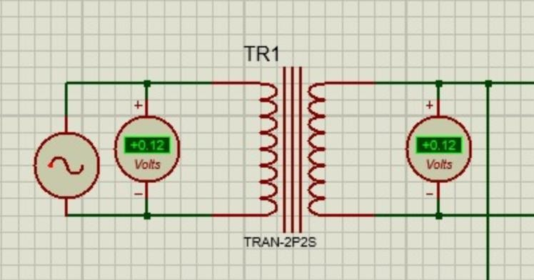
Since output voltage is taken across two capacitors, hence It will be 2𝑉𝑝𝑘.
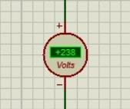

2.2 Voltage Tripler: -
It can be constructed by using an additional diodes and capacitors with the half wave rectifier as shown in the figure below:

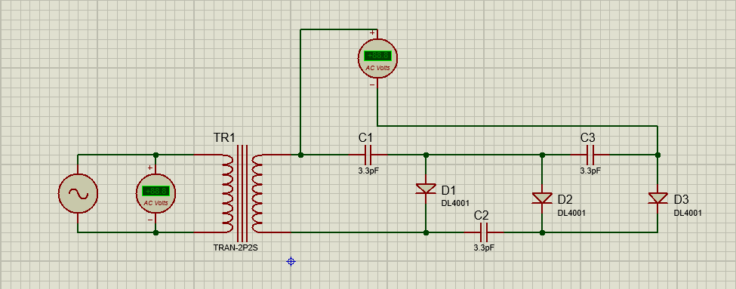
During -ve half cycle D1 is forward bias and charges c1 to a peak value Vpk. During +ve half cycle C2 is charged to 2 Vpk and C3 is also charged to 2 Vpk. The output voltage across RL is the sum of voltage across C1 and C3.
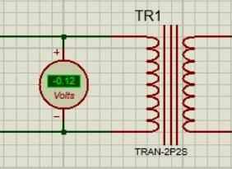
Hence the output voltage will be 3Vpk.

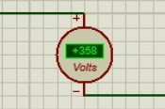
3.OPAMP
  - ​Inverting Amplifier: -
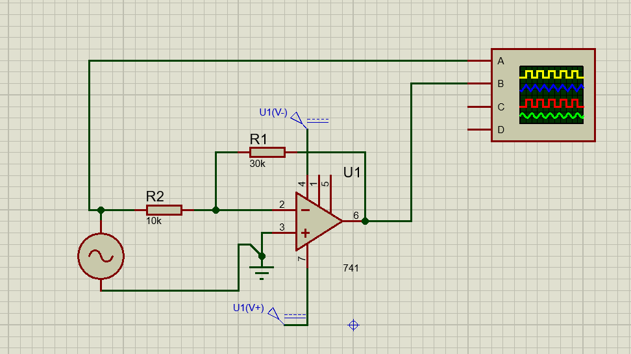

Input is applied to the inverting terminal (-). Thus, the output is phase-shifted by 180°. The amount of amplification that is closed loop gain is given by –(Rf/Rin)
Vout = - (Rf / Rin) Vin Av = - (Rf / Rin)
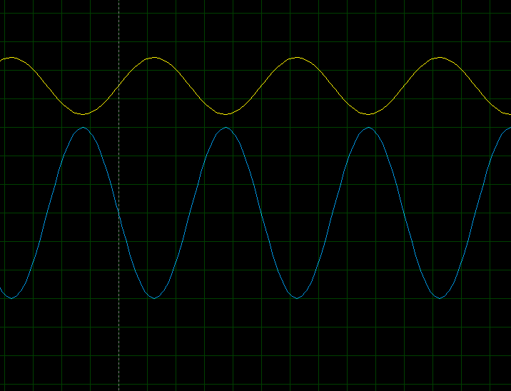

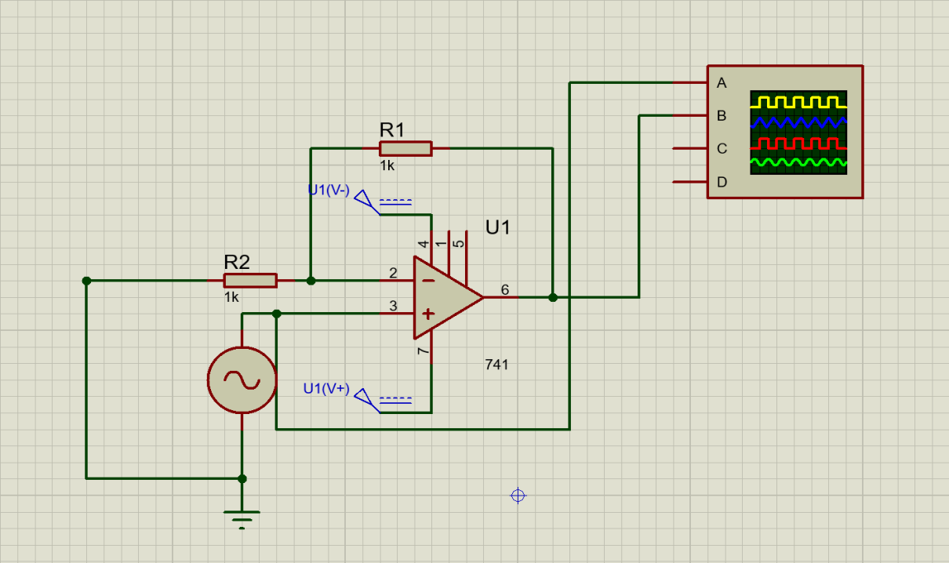
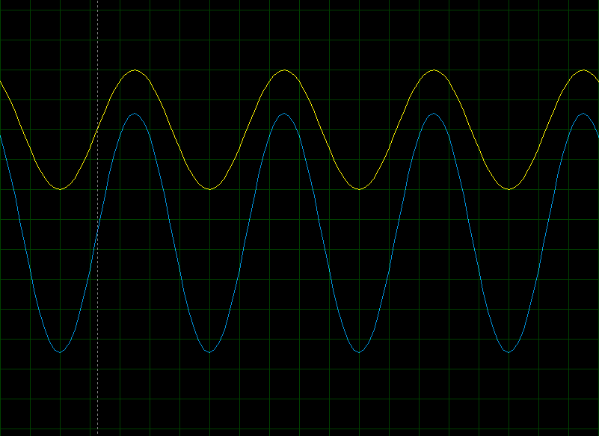
  - ​Non-Inverting Amplifier: -

The input is applied at the non-inverting terminal (+). Hence, the output will be in phase (0°). The gain of the non-inverting amplifier is given by (1+Rf/Ri)
Vout = (1 + Rf / Rin) Vin Av = (1 + Rf / Rin)

3.3 Differentiator: -
The circuit produces the differentiation of the input voltage at its output voltage is called Differentiator. The circuit is as shown below,

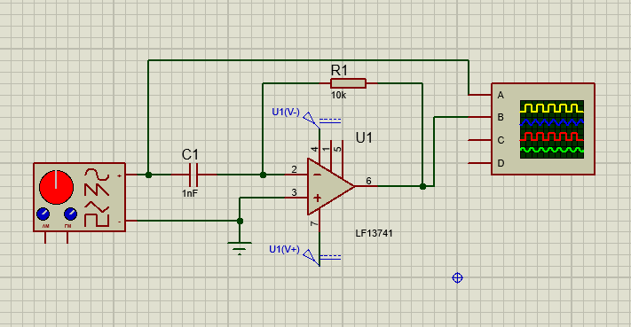

The square wave input is converted into a train of short duration pulses. The output is inverted because the input is applied at the inverting terminal. The graph is shown below,

3.4 Summing amplifier: -
It is the circuit which produces the output voltage which is sum of input voltage applied.
V _{out} = - ( R_{f} /R₁ ) V₁ - ( R_{f} /R₂ ) V₂
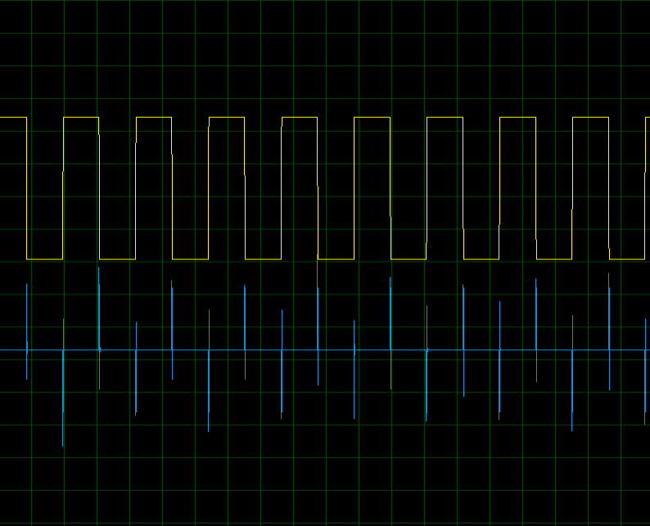
if R₁ = R₂ = R , V _{out} = - R_{f} /R ( V₁ + V₂ ) if R_{f} = R , V _{out} = - ( V₁ + V₂ )
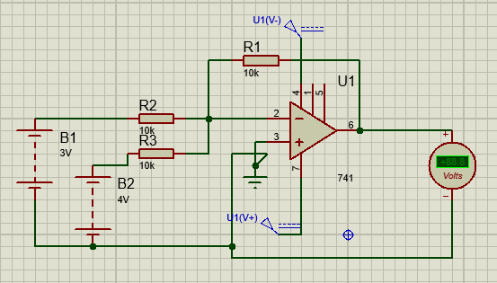

Output: -
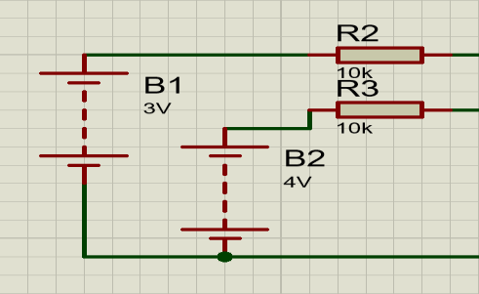
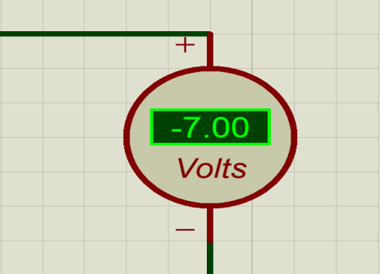
3.5 Astable oscillator: -
A simple single stage astable oscillator using an OPAMP is showed in the figure below. The circuit employs positive feedback without output feedback to non-inverting input via potential divider formed by R1 and R2.
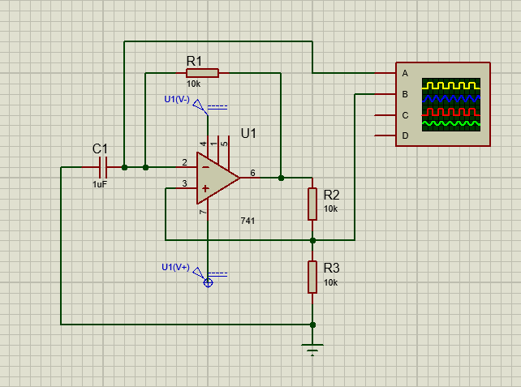
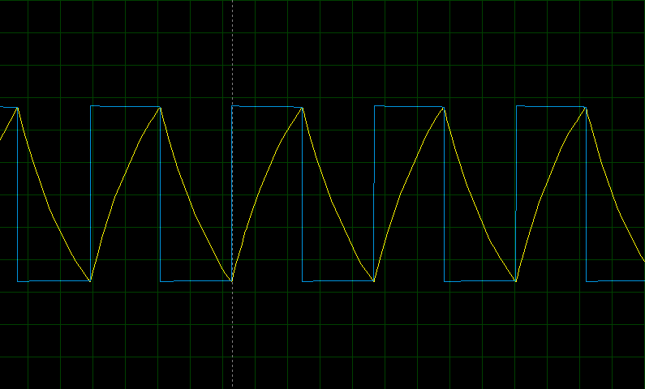

- ​Adder
  - ​Half Adder: -
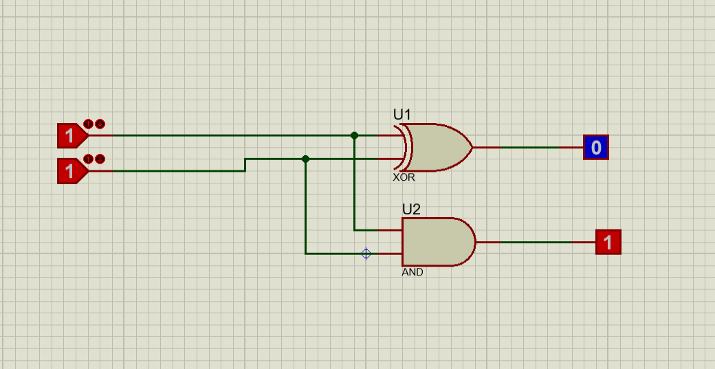

Half adder which has 2 bits x and y and generates 2 output bits has sum and carry designed as s and c

Truth table: -

x | y | c | s
0 | 0 | 0 | 0
0 | 1 | 0 | 1
1 | 0 | 0 | 1
1 | 1 | 1 | 0

Operation: - Sum = A⊕B Carry = A⋅B

  - ​Full adder: -
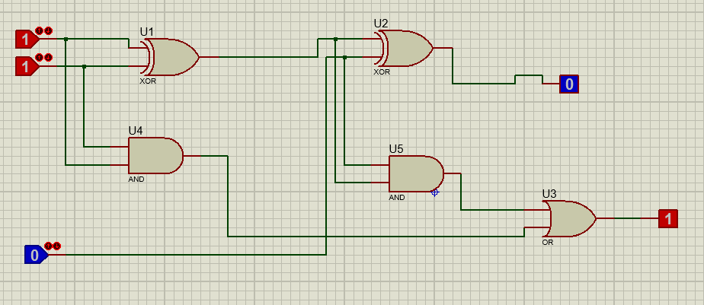

Full Adder is a combination circuit which adds 3 bits in which 2 bits are to be added and 3rd bit is carry input from previous bit position addition, and generates outputs Sum and a carry output

Truth Table: -

x | y | z | c | s
0 | 0 | 0 | 0 | 0
0 | 0 | 1 | 0 | 1
0 | 1 | 0 | 0 | 1
0 | 1 | 1 | 1 | 0
1 | 0 | 0 | 0 | 1
1 | 0 | 1 | 1 | 0
1 | 1 | 0 | 1 | 0
1 | 1 | 1 | 1 | 1

Operations: -
Sum = A⊕B⊕C
C =(A⋅B)+(B⋅Cin )+(A⋅Cin)
- ​Modulator
  - ​Amplitude Modulation: -
Amplitude Modulation (AM) is a technique where the amplitude of a high-frequency carrier wave is varied in proportion to the information signal, such as audio.
